By: Sally Phan
Year: 10IT

Double Exposure effect – Woman Tree

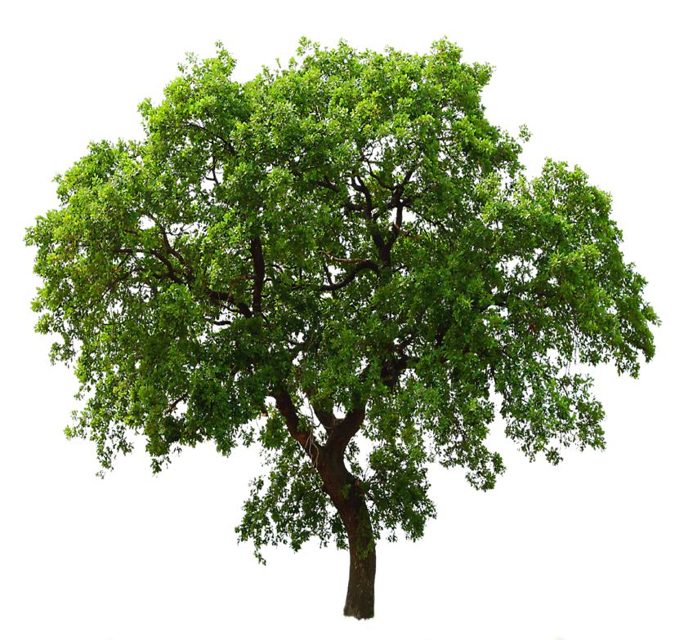

Step 1:

- Open the woman image and the tree on Photoshop.
- The first thing select the Quick Selection Tool and select around the woman. Then unlock her image, create a new layer on this layer and then create a new layer then put it under that layer and filling it white colour.

Step 2:

- Let fo to the tree layer then Ctrl + C, Ctrl + D, go back the woman layer and Ctrl + V. It got the tree from the background then Ctrl +T to make the tree bigger and also move to the way I want it to be.
- Click on the woman layer and Ctrl + T to make her smaller a bit. Everything is already, click to the Lighten. Click on the tree layer again Ctrl + T to make sure it on the way I want then Enter.

Step 3:

- Select the Woman layer, Ctrl and Click on it, it look selection on this. Go to select and Inverse.
- Go and select the tree layer, click on Brush tool make it black and remove the tree outside only the tree on the left hand then Ctrl + D.
- Then remove the tree on the right hand. Select the woman layer and put a black colour a bit. Go and select Lasso Tool to selection around the tree then used brush to this select to get it out then Ctrl + D to get out the select.
Step 4:

- Go to the Brush and select the brush 60 been it white colour and click on tree, then go to the Shape Dynamics to make the shape bigger.
- Copy her layer and Delete Mask then put on normal, apply layer mask again and filling black colour, select the brush and used the normal brush click with the white colour and put it on her face.

Step 5:

- Select the woman first layer and go to Image click on Adjustments -> Desaturate, then do the same with the second layer.
- Go to the Solid Colour and make it dark blue then click to Exclusion turn down the Opacity a bit .
- Created the new layer, select the brush with the black make it big and do it around the the corner then turn the Opacity down until get the colour I like.

Step 5:
- Save it in JPG.
Here we go:

